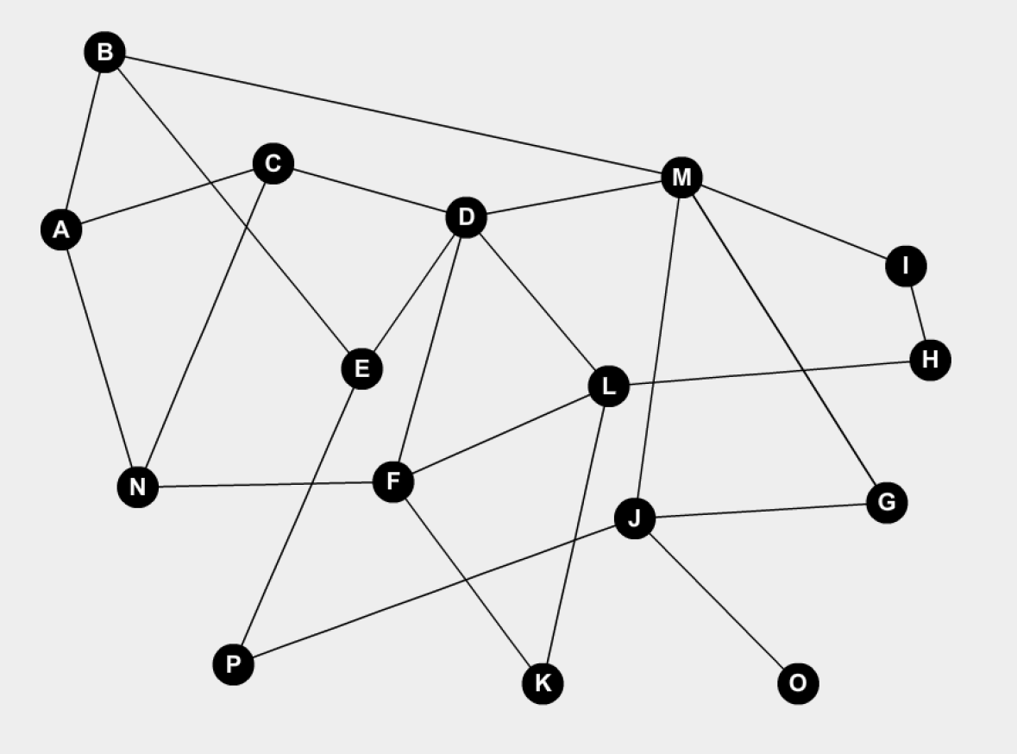

DFS –

Source Vertex – M

Stack (visited):

M

D

L

H

I

K

F

N

C

A

B

E

P

J

O

Current stack:

M D L H I K F N C A B E P J O - pop

M D L H I K F N C A B E P J – G

All vertices visited = pop all

Current stack: Empty

Expression: M D L H I K F N C A B E P J O G

BFS –

Source Vertex – M

Queue: I B J G D – Dequeue all

Current Queue: H – Dequeue all

Current Queue: E A – Dequeue all

Current Queue: P – Dequeue all

Current Queue: O – Dequeue all

Current Queue: C F L – Dequeue all

Current Queue: N – Dequeue all

Current Queue: K – Dequeue all

Expression: M I B J G D H E A P O C F L N K